JOL ENERGY BUSINESS DASHBOARD

Name:MOWNIKASRI.R
College Name:Vellore Institute Of Technology
Department:Intergrated M.Tech Software Engineering
Academic Year:4th year

1. Objective
The objective of this project is to develop a Power BI dashboard for JOL Energy to monitor supplier activities, buyer activities, collection network performance, and market intelligence data. The dashboard helps visualize business performance and supports decision-making through interactive charts and KPIs.
2. Tools Used
- Microsoft Excel
- Microsoft Power BI
3. Dataset Description
The dataset consists of four sections:
Supplier Pipeline
- Leads Generated
- Contacted
- Qualified
- Interested
- LOI Received
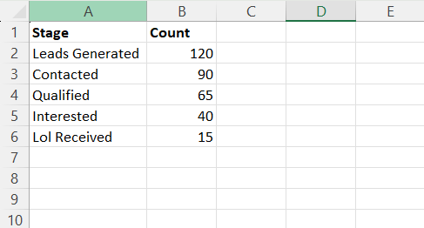
Buyer Pipeline
- Leads Generated
- Contacted
- Sample Requested
- Discussion Stage
- LOI Received
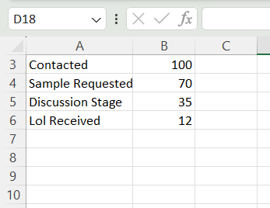
Collection Network
- Collection Points
- Geographic Coverage
- Estimated Monthly Volumes
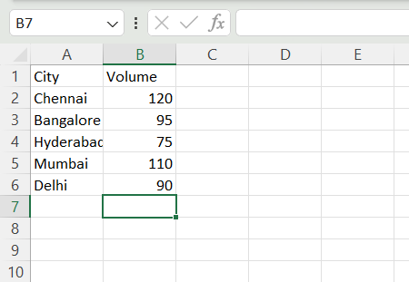
Market Intelligence
- Lithium Prices
- Nickel Prices
- Cobalt Prices
- Battery Scrap Prices

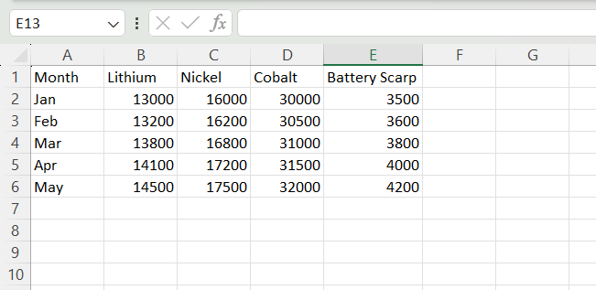
4. Visualizations Used
Funnel Charts
Used to analyze Supplier Pipeline and Buyer Pipeline conversion stages.
Bar Chart
Used to compare collection volumes across different cities.
Line Chart
Used to analyze trends in lithium, nickel, cobalt, and battery scrap prices over time.
KPI Cards
Used to display key business metrics such as total leads, LOIs received, and total collection volume.
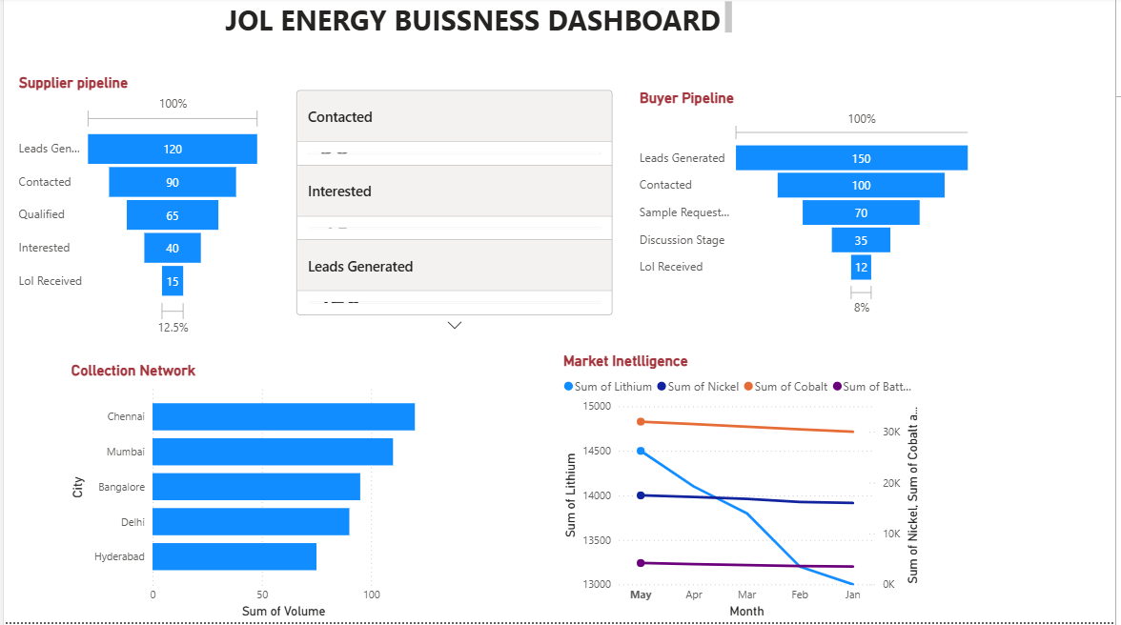
5. Key Insights
- Supplier conversion rate is approximately 12.5%.
- Buyer conversion rate is approximately 8%.
- Chennai has the highest collection volume.
- Lithium prices show a gradual increase over time.
- Collection activities are concentrated in major metropolitan cities.
6. Recommendations
- Increase supplier outreach to improve lead generation.
- Focus on converting qualified suppliers into active partners.
- Expand collection centers in high-volume regions.
- Monitor market price fluctuations regularly.
- Strengthen relationships with buyers to increase LOI conversions.
7. Conclusion
The JOL Energy Business Dashboard provides a clear overview of supplier management, buyer engagement, collection network performance, and market trends. The dashboard enables better business monitoring and supports data-driven decision-making.

